(Official HD Photo) (Past your official University/Organization Logo)

Title: Compliance XXXXXXX for Febrile Neutropenia XXXXX Filipino Patients XXXXXX
Name: XXXXX
University/Organization; City, State and Country: XXXXX
(If any co-authors please mention with name and university, Country)

Abstract: (Minimum 250 words - Maximum 400 words)
Febrile neutropenia (FN) is a common complication of immunocompromised patients –whether due to infection, cancer, drug-induced, or other bone marrow failure states. With the incidence of patients with XXXXX on the rise, this life threatening complication is also increasing. The importance of initiating the appropriate empiric XXXXXX can prove to be life-saving, thus we examined how the initial choice of antibiotics influenced patient outcomes.
Among the 257 adult patients with FN included in the study, guideline-based antibiotics were XXXXXXX On multivariate analysis, the most powerful predictor of adherence to guideline-based antibiotics was the type of risk (p=0.000), with high risk patients thrice more likely to be given guideline-based antibiotics. Other predictors were physician specialty (p= 0.036) and XXXXXXX (p=0.045). This study showed that among low risk patients with FN, a trend towards patient discharge was observed (OR 1.18, CI = 0.16 – 8.63). However overall, adherence to guideline-based XXXXXX in treating adult FN patients did not correlate to patient discharge (p=0.134, OR 0.557, 95% CI = 0.260-1.205).
Keywords: Colposcopy / ACOG, Pelvic organ prolapse, xxxxxx
Images/Graphs/Tables: (If any Images please keep here in high quality)
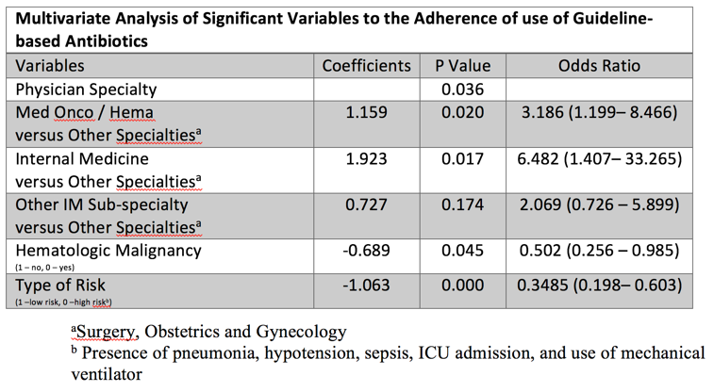

Biography: (Minimum 150 words - Maximum 250 words)
XXXX has completed his PhD in the year 1980 at the age of 25 years from XXX University. He is the Professor/director of XXXX, a premier Bio-Soft service organization. He has published more than 25 papers in reputed journals and has been serving as an editorial board member of repute.
Presenting author details:
Full name (As per the passport):
University/Industry/Organization name (Present working):
Designation (Director/Prof/Assistant or Associate prof/Researcher/ Scientist /PhD Student):
Country:
Mobile number (country code – number):
Official Email ID:
Presentation type (Oral/Poster):
Category (Keynote/ Speaker/ YRF):
Track Name (*This is very important to schedule your talk):
Research interest:
Your profile page URL in your department:
Date of birth as per the passport:
Linked In/Facebook/twitter account:
Postal address:
Note: Please fill up the Blue mark fields so that it would be easier for us to cite your details in the conference particulars. (Please do not forget to fix your photo and Logo above the title)

